**Business Analyst Career Program**

**Internship Project**

Hello Learners,

We are excited to finally announce the Internship Project. This project is your opportunity to present your Business Analytics skills. The project includes Product Sales and Customer Data.

You have to use your Business analytics skills and perform Statistical analysis using Business Intelligence Tools such as Power BI or Tableau.

Present your project using **Slides/PPT** with reference to the below mentioned actionables and make appropriate use of relevant tools and technologies to derive Insights from data and Make a Dashboard to show your analysis.

**Problem Statement:**

**Perform Business Analysis by using PowerBI or Tableau on Product Sales and Customer Data Dataset. Explore the Data and perform the below mentioned Actionables. Make a PPT for the Internship Project including the relevant Picture of Graphs and Plots & PowerBI or Tableau files , Inferences and conclusion.**

**Download the Dataset from here.**

* [**Product Sales Data**](https://drive.google.com/uc?export=download&id=142bcqOT9g9ofqcUNE8nRJBFloakWLWlU)
* [**Customer Data**](https://drive.google.com/uc?export=download&id=1RmBA3vjcQyod9owFgyj7STU1irbotlcz)

**Actionables:**

1. Import the Data which is in a JSON file into PowerBI ,verify if the data is properly imported or not.
2. Perform Data cleaning and other possible operations on data using query editor ,create measures if necessary and use them to visualize the data and make an interactive visualization.
3. Make a Detailed Interactive Dashboard by using visualization tools such as PowerBI and Answer the following questions :

* Transform customers data so that firstName, MiddleName and LastName are merged into full name.
* Delete column demographics..
* Create measures like TotalSalesAmount.
* Create a measure like Average,Min,Max TotalSalesAmount.
* Which customer has the highest SalesAmount?
* Which customer has the minimum sales amount?
* Which Product category is having the highest sales?
* Show month over month Sales Amount.

1. Create a Visually pleasing Dashboard report by following the rules of making the Dashboard.
2. Derive Conclusion and Inferences from the Dashboard.

**Please Submit Your Internship Project using a PPT and insert required files in it , For reference please refer** [**Internship Project Guide**](https://docs.google.com/presentation/d/105t5NRCwC_pahTZYeOl_6qy2Ka8o7CA-8GHrixFlN7E/edit?usp=sharing)**.**

**The deadline to submit the project is 22nd April, 2023** **. This Internship project is of 100 marks ,so plz perform every step of the project carefully and properly document it in the PPT.**

**Process for Submission**

Please upload your assignment files via this[**Google Form**](https://docs.google.com/forms/d/e/1FAIpQLScqxYlMN5x4awwtZPWuUl1SqDFCE8Wj4TpkeGvhndib0UkKdg/viewform?usp=pp_url&entry.741659221=Business+Analyst+Career+Program+-+Internship+Project)before the deadline (22nd April, 2023 11:59 pm).

**Steps to submit the assignment:**

1. Open the Google Form.
2. Enter your email id, name, assignment name.
3. And upload the assignment file by clicking the Add file button.



1. You can upload the file by clicking Select file from your device or by dragging the file and dropping it in the window opened.



1. Select your assignment file and click the Open button.
2. After selecting the file click on the Upload button.

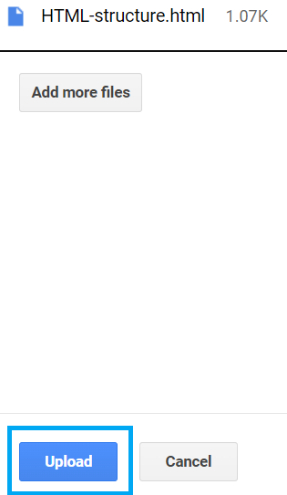

1. Once the file is uploaded, click on the Submit button.

